**TASK 1**

#include<iostream>

using namespace std;

void calarea(int&, int&);

void calarea(float &, float&);

void calarea(double &, double&);

void calarea(int &);

void calarea(float&);

void calarea(double&);

int main()

{

double l, w;

double r;

int op;

cout << "Enter choice 1 for area of circle and 2 for area of rectangle ";

cin >> op;

if (op == 1)

{

cout << "Enter radius of a circle ";

cin >> r;

calarea(r);

}

if (op == 2)

{

cout << "Enter lenght and width of a circle ";

cin >> l>>w;

calarea(l, w);

}

system("pause");

}

void calarea(int &l, int &w)

{

cout <<"Area of rectangle " <<l*w<<endl;

}

void calarea(float &l, float &w)

{

cout << "Area of rectangle"<<l*w;

}

void calarea(double &l, double &w)

{

cout << "Area of rectangle" << l*w;

}

void calarea(int&r)

{

cout << "Area of circle " << 3.14*r*r;

}

void calarea(float&r)

{

cout << "Area of circle " << 3.14*r*r;

}

void calarea(double&r)

{

cout << "Area of circle " << 3.14*r*r;

}

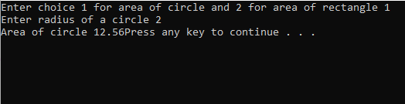

**TASK 2:**

#include<iostream>

using namespace std;

void add(int&a, int &b)

{

cout << a + b;

}

void add(float&a, float &b)

{

cout << a + b;

}

void subtract(int&a, int &b)

{

cout << a - b;

}

void subtract(float&a, float &b)

{

cout << a - b;

}

void multiply(int&a, int &b)

{

cout << a * b;

}

void multiply(float&a, float &b)

{

cout << a * b;

}

void divide(int&a, int &b)

{

cout << a / b;

}

void divide(float&a, float &b)

{

cout << a / b;

}

int main()

{

float a, b;

int op;

cout << "Enter value of a and value of b";

cin >> a >> b;

cout << "Enter 1 for addition" << endl<<"Enter 2 for subtraction"<<endl;

cout << "Enter 3 for multiplication" << endl << "Enter 4 for division" << endl << "Enter 5 for Exit"<<endl;

cin >> op;

switch (op)

{

case 1:

add(a,b);

break;

case 2:

subtract(a, b);

break;

case 3:

multiply(a, b);

break;

case 4:

divide(a, b);

break;

}

system("pause");

}

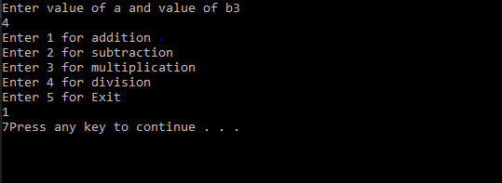

**TASK 3:**

#include<iostream>

using namespace std;

void daydiff(int&sum1, int&sum)

{

int x = sum1 - sum;

cout << x << "is the difference of days";

}

int main()

{

int date, month, year;

int date1, month1, year1;

int sum = 0,sum1=0;

cout << "Enter 1st date";

cin >> date;

cout << "Enter 1st month";

cin >> month;

cout << "Enter 1st year ";

cin >> year;

cout << endl;

cout << "Enter 2nd date";

cin >> date1;

cout << "Enter 2nd month";

cin >> month1;

cout << "Enter 2nd year ";

cin >> year1;

sum = date + (month * 30) + (year*365);

sum1 = date1 + (month1 * 30) + (year1*365);

daydiff(sum, sum1);

system("pause");

}

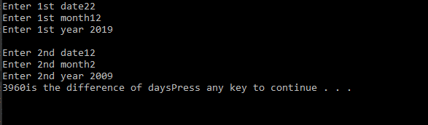

**TASK 4:**

#include<iostream>

using namespace std;

void daydiff(int &sum)

{

cout << sum;

if (sum / 4 == 0 || sum/400==0)

cout <<endl <<"The year entered is leap"<<endl;

}

int main()

{

int date, month, year;

int sum = 0;

cout << "Enter 1st date";

cin >> date;

cout << "Enter 1st month";

cin >> month;

cout << "Enter 1st year ";

cin >> year;

sum = date +((month-1) * 30) ;

daydiff(sum);

system("pause");

}

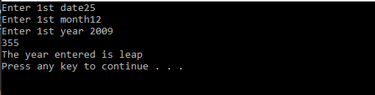

**TASK 5:**

#include<iostream>

#include<cmath>

using namespace std;

double instalment ( double l, double r,double t,double m);

double remaining (double b,double m,double t,double r);

int main()

{

int a;

double L, r, m, t, i, R, option=1;

while(1)

{

cout<<"Enter 1 to Proceed, 0 to Exit: "<<endl;

cin>>option;

if(option!=1)

{

break;

}

cout<<"Enter the Amount of Loan: ";

cin>>L;

cout<<"Enter Rate of Interest per Year(in %): "<<endl;

cin>>r;

cout<<"Enter Number of Payments per Year: "<<endl;

cin>>m;

cout<<"Enter Total Span (in years): "<<endl;

cin>>t;

R=instalment(L,r,t,m);

cout<<"The Periodic Payment is: "<<R<<endl;

cout<<"The Remaining Amount is: "<<remaining(R,m,t,r);

}

}

double instalment( double l, double r,double t,double m)

{

float i=r/m;

double g=pow((1+i),-m*t);

return (l*i / 1 )-g;

}

double remaining(double b,double m,double t,double r)

{

int k;

float i=r/m;

cout<<"How Many Payments Have you Gave: ";

cin>>k;

double h=pow(1+i,-(m*t-k));

return b*(1-h);

}

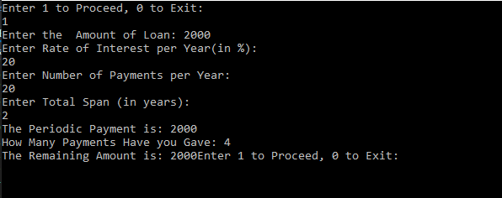

**TASK 6:**

#include<iostream>

using namespace std;

void inflationrate(float&a, float&b)//function definition

{

cout << "Enter amount of first year";

cin >> a;

cout << "Enter amount of second year";

cin >> b;

}

void calinflationrate(float&a, float&b) //function definition

{

float x = (b - a) / a;

cout << x<<endl;

}

void output(float &a,float&b) //function definition

{

calinflationrate(a, b);

}

int main()

{

float a, b, x;

inflationrate(a, b);

calinflationrate(a, b);

output(a,b);

system("pause");

}

